Author: Michael Ordoukhani
Web Site: orodoukhani.com
Title: Making Diamonds
Last Saved on: 05 February 2016
Making Diamonds

Contents
0
Agreement 1
Introduction 2
Atomic structure 3
How natural diamonds are created 3
The secret of diamond formation 4
How to create an artificial diamond 5

Agreement

The idea described should not be used or passed to the third party without my consent, collaboration and a signed agreement.

Introduction
Diamonds are one of the rarest of elements found on Earth, with unique properties that make them the most valuable of elements. However, despite their uniqueness, they are made of Carbon, one the most abundant element on Earth and in the universe. A diamond is identical to Graphite (Fig 1), which can be produced and found in nature, except they have a different molecular structure (Fig. 2). So diamonds are not rare elements but have a very rare structure.
It is believed that diamonds are only formed in environments with extremely high temperature and pressure. That assumption is partly correct, but unlike fusion and fission, the energy required to transform graphite into a diamond is not stored in the diamonds or released when one is converted to another. It therefore means that the energy is not an essential requirement of the process and can be done away with. This is the purpose of this document to explain how we can bypass the extreme conversion process into a simple one.
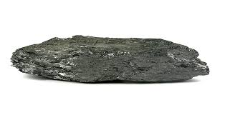 | 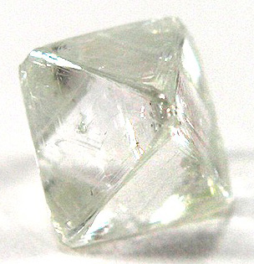
Graphite | Diamond
Figure 1 – Natural Diamond and Graphite
In 2000, when I came up with this method, there was no one making artificial diamond at that time. But since then a company has started making quality diamonds using a similar method to this. Interestingly they have made more yellow diamonds, which much rarer than clear ones. They described their method in a documentary which was made about them. For security reasons the reporter was blind-folded to keep the location of the factory a secret. It showed how they used a small vacuum chamber and bombarded the diamond seed with special gas (they kept the details a secret) and over a long time the diamond grew. I also realised the process they are using is slow and costly but the profit margin was high. The diamond experts compared their diamond with a natural one and could not tell the difference between them. However, the real diamonds come with certificates that certifies their origin so they artificial ones may be less valuable in the market. I have to hold some reservation for genuinely of that company. There might be a possibility that they did not make real diamonds as large as they claim.
Industrial diamonds have been artificially made for a long time but they have not managed to make jewellery quality diamonds yet. The industrial diamonds are not clear and they can only produce them in sheets, suitable for grinding and drilling machines.
Here I am showing a method to create diamonds artificially at low cost at around room temperature. I have not experimented, tested nor produced anything, so it is all a theory. The reason I am disclosing this method is to gain some recognition for investors to back my MOTE idea which I am keeping a secret until an investment has been made.

Atomic structure

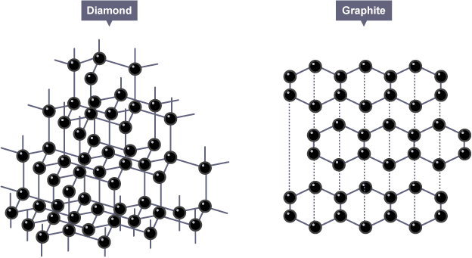
Figure 2 – Diamond and Graphite atomic structure

How natural diamonds are created
There three factors required to create diamond are carbon, heat and pressure.
Carbon is found in plenty in atmosphere as CO₂, as oil in Earth crust and is produced at a by-product of volcanic eruption. CO₂ is absorbed by plants in the sea and on land and is turned into wood and other compounds that when burnt produces charcoal and graphite. Living creatures are mostly maid of carbon which is the foundation of life on Earth. When life started on Earth in the sea, the organism filled the oceans and their remains rested and accumulated on sea floors as sediments. The continental plate movement melted and compressed these sediments under the Earth crust. This process provided the conditions needed for formation of diamonds. Since colliding continental plates also create volcanos and mountains, the buried diamonds are move up to surface and ejected out of the volcanos, so natural diamonds are always found in the areas around volcanos.
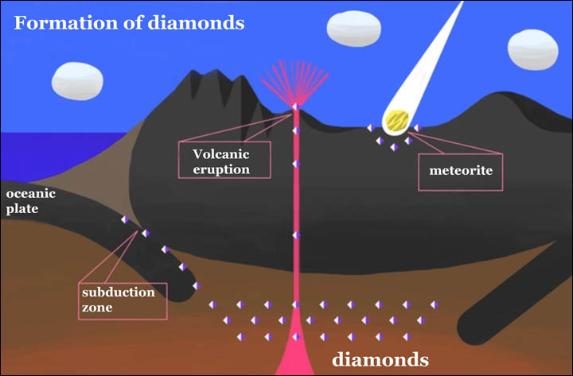
Figure 3 - Natural Diamond Formation

The secret of diamond formation
This is my own understanding of the process of diamond formation, which I have not heard anywhere else. It is believed that enormous amount of heat and pressure is required to form diamonds, but no explanation has been given why. What made me curious was the fact that, unlike fossil fuel, which is produced due to same process requiring pressure and temperature but absorbs some of the energy in its chemical bounding and released when burnt, the energy and heat spent in producing diamonds is not stored in the end product. So heat and pressure is not an essential requirement for the formation do diamonds. Understanding that will show that diamond structure is no more difficult to produce that graphite if approached in the correct way. Here I explain why:
Carbon atom vibrates at room temperature like other atoms. Since carbon is not a noble gas, it will combine with another carbon creating a strong covalent bound, if there are no other elements present. Due to the shape and number of free electrons, by default, carbon atoms combine in a hexagonal manner. Even though there are at least five different structures carbon atoms can combine together, at room temperature the graphite structure always has precedence over any other ones. If we subject the gas to some heat that agitates the carbon.
Now, if the carbon atoms are subject to increasing levels of heat, it will agitate the atoms until a point where the bounding of atoms can no longer hold and the atoms start moving around freely either as gas or liquid (depending of the element). So as long as the temperature is kept above that threshold, the carbon atoms do not form into graphite. But since there are other atomic structures that which are far more stable, but increasing the heat the chance of the atoms forming at least one of that type becomes likely. That is, since the temperature is high enough to stop graphite forming the only possible structure possible would be a diamond lattice. Since the atoms are free due to high heat that becomes a possibility. The reason why pressure has to be also high, is that the atoms move away from each other when the temperature gets higher, so by exerting pressure it keeps the atoms together. So over time if only 5 atoms form a diamond structure that initiates the processes. The heat and pressure no longer can dislodge those 5 atoms. So if the heat and pressure is kept high enough gradually the rest of the atoms add to that seed and become stable and stop agitating until all the atoms in that bubble is turned into diamonds, after that the heat and pressure has no effect on the diamond.
A diamond has a free unoccupied bound at every carbon atom on its surface, so it completes it with a layer of Hydrogen. So when you touch a diamond you are in fact feeling a layer of hydrogen rather than carbon as in graphite.
So the real this is the real reason why heat and pressure are required. Because the diamond structure is stable at a temperature that is too hot for graphite structure is hold its form. Since when diamond structure is formed it becomes extremely stable it will remain a diamond for ever.
I like to give an analogy to visualise this in another way. If a room with no air flow you get dust settling down. If there is slight air flow, it agitates the dust so it is unable to settle, but if you look in a corner of the room you see fluff of dust building up. That is because that fluff has found a stable structure that cannot be disturbed by that level of air flow. If the air flow increases, that fluff also gets broken up and something much more stable may take form. That is how trees evolve. Over millions of years the ideal design survives and the weaker one gets destroyed by the wind. So in places here wind level never gets high those designs do not exist.

How to create an artificial diamond
This is just a theoretical method based on these suppositions:
- Diamonds and graphite differ only in their structure.
- Heat and pressure is not essential criteria in turning graphite into diamond.
- Diamond have a free bound at their outer layer which is commonly bounded with H atom
- Hydrogen-carbon bound can be broken easily and replaced with another carbon atom
By using an existing diamond as seed, the diamond must be place in sealed chamber filled with Argon gas to prevent anything but carbon gas bounding with the diamond.
To knock out the Hydrogen at the outer layer and replace it with a carbon atom, it is subjected to a high flow of CH₄ gas. The trick is to ensure the gas hits the atom at the right speed and energy to knock it out and replace it. If that is not considered or measured very accurately many attempt will fail leading to assumption that the process is flawed and is therefore abandoned.
The reason CH₄ is used is that it contains a single Carbon atom and it is already surrounded by four Hydrogen atoms, making is balanced and therefore the bounding easier.
Using a high-power beam of ultraviolet light would excite the outer hydrogen layer and make them more susceptible to exchange of H to C.
Since heat and pressure is omitted from the process the processes will take time, but it will be cheaper.
This all can be calculated based on the probability of atoms hitting each other in the right way. In nature extreme heat and pressure increases this probability by billions, but this method can produce diamond if these factors are accurately controlled.

Methane
Diamond

Figure 4 - Natural Diamond Formation

